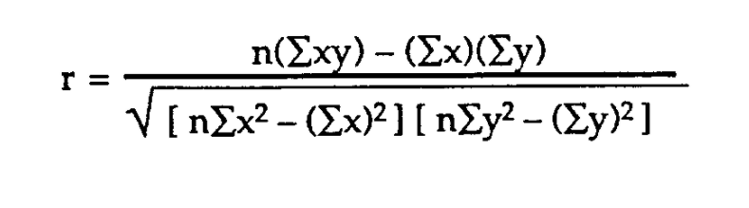

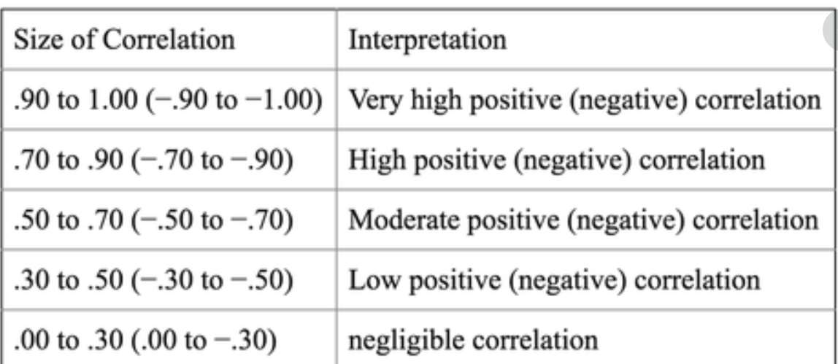

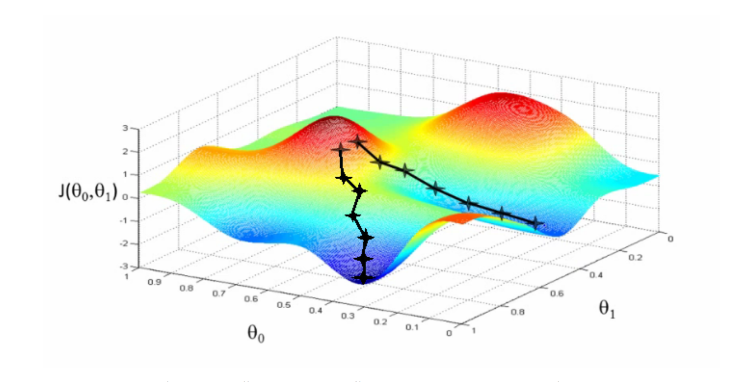

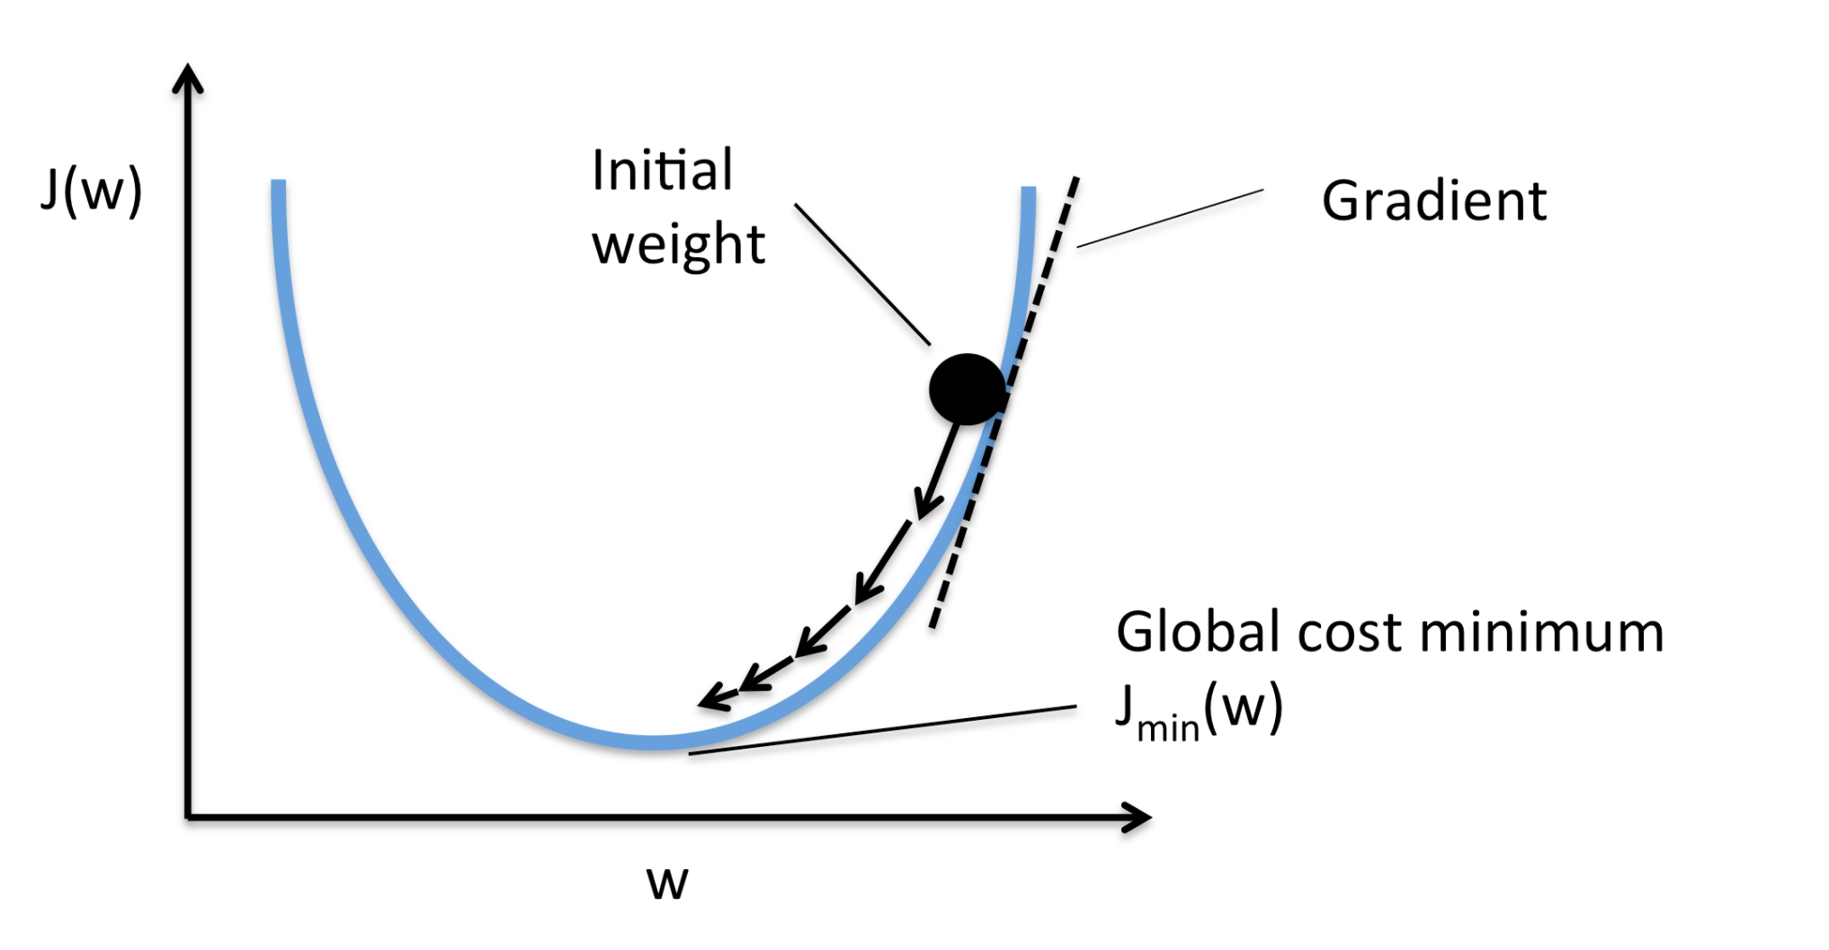

Bias - Variance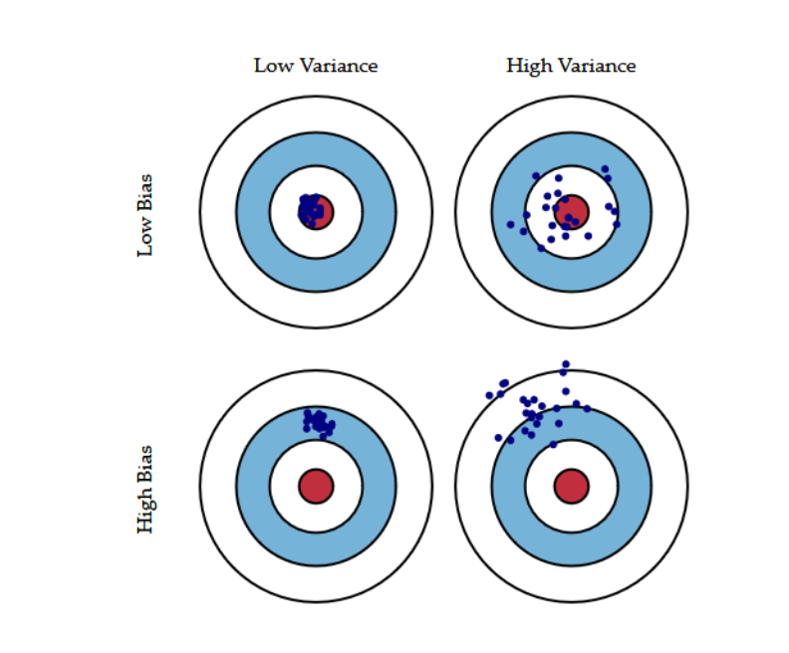

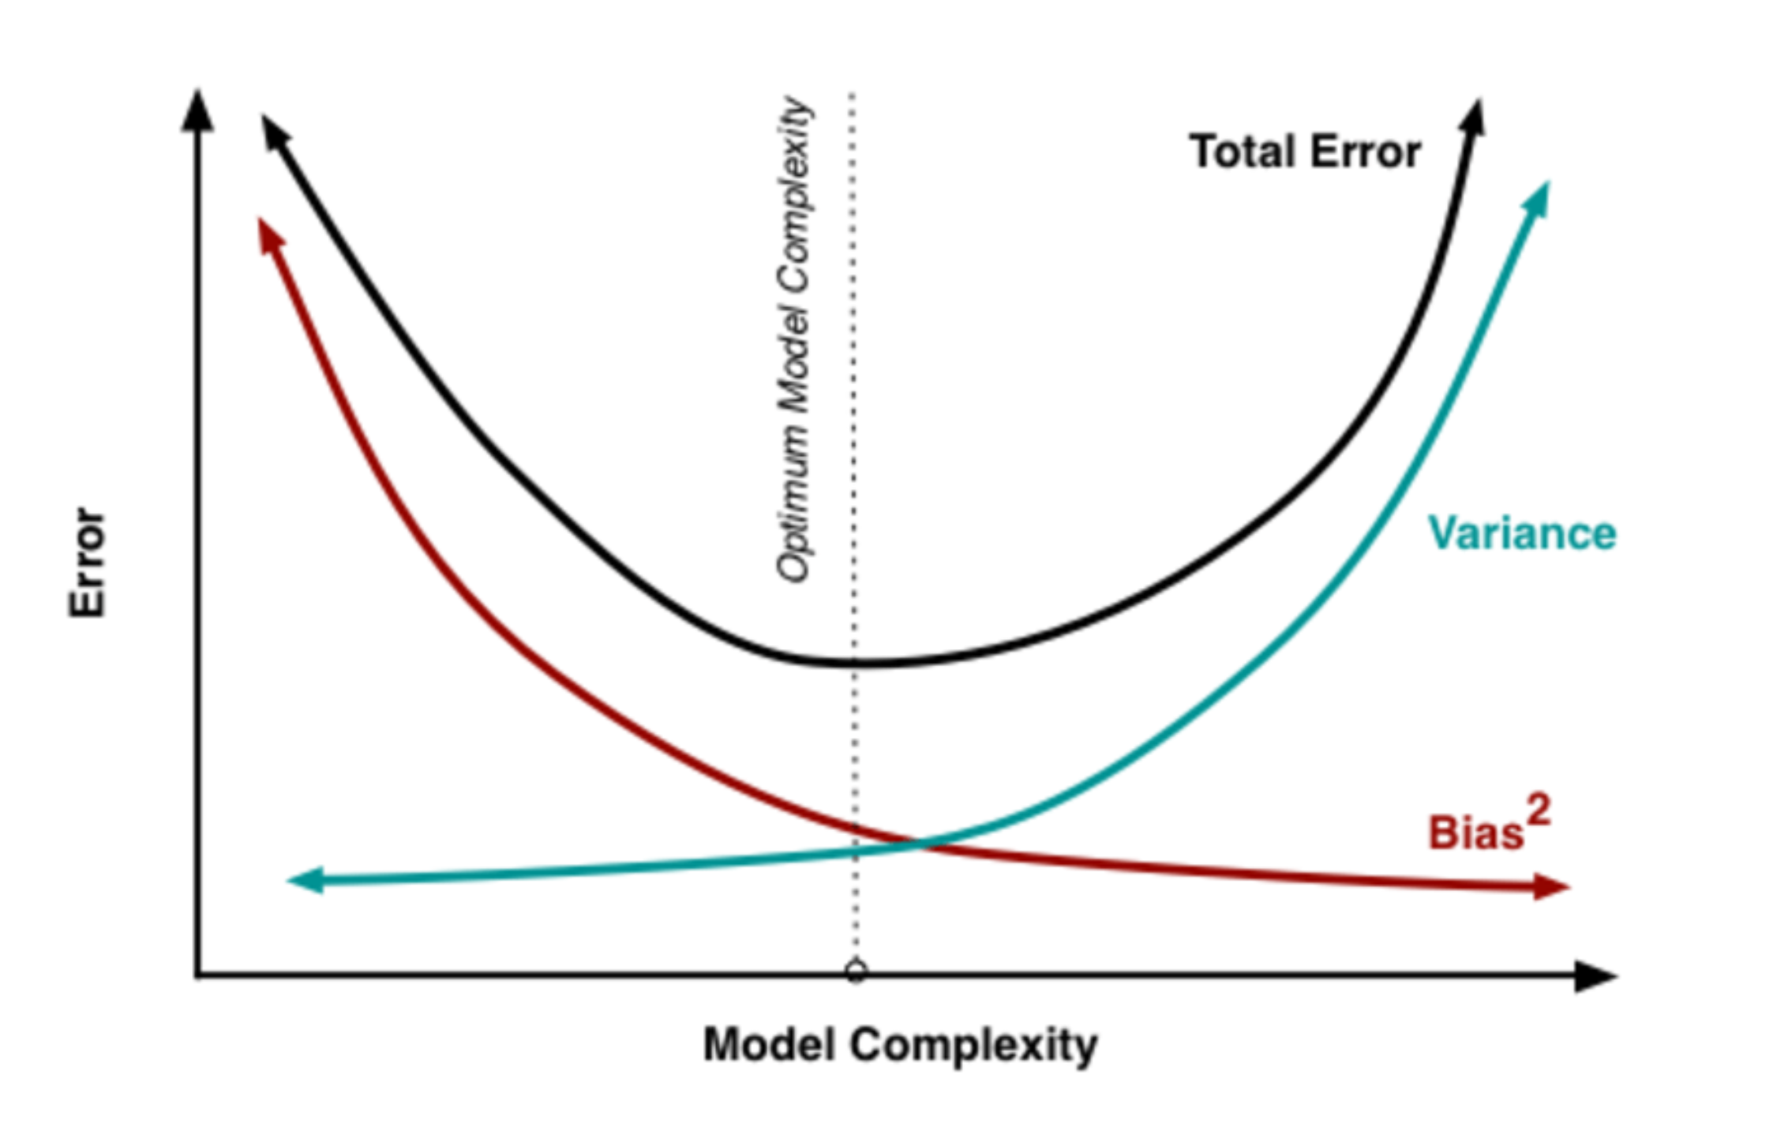

LASSO Regression

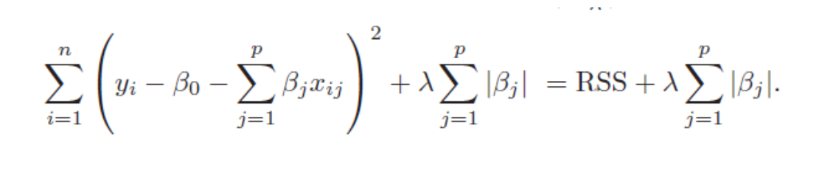

A [**tuning parameter**](https://www.statisticshowto.com/tuning-parameter/), λ controls the strength of the L1 penalty. λ is basically the amount of shrinkage:

* When λ = 0, no parameters are eliminated. The estimate is equal to the one found with linear regression.
* As λ increases, more and more coefficients are set to zero and eliminated (theoretically, when λ = ∞, all coefficients are eliminated).
* As λ increases, [bias](https://www.statisticshowto.com/what-is-bias/)increases.
* As λ decreases, [variance](https://www.statisticshowto.com/probability-and-statistics/variance/)increases

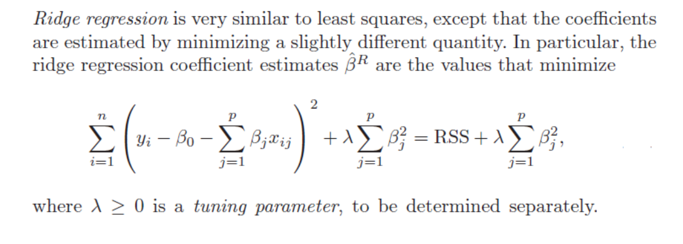

**Significance of Intercept**

**The intercept is defined as the mean of the dependent variable when you set all of the independent variables in your model to zero.**

Hypothesis Testing for feature significance test

* **Null Hypothesis:** The independent variable has no significant effect over the target variable
* **Alternate Hypothesis:** The independent variables have a significant effect on the target variable

*Features that has p-value above the statistically significant values then we can interpret as they are not adding much value in explaining the variation in my target feature*

Hypothesis Testing for Model significance test

*F-Statistics (or F-test)*

It is used to assess the significance of the overall regression model.

In MLR, where we deal with multiple features. It compares the model with no predictor i.e. Intercept- Only model, to the given model .

Null Hypothesis: The two models are equal

Alternate Hypothesis: The two models are not equal and Intercept-Only model is worse than our model.

If the F-statistic value is very large and P-value is close to zero than we can reject the Null hypothesis.